**TUTA PRACTICE EXAM GUIDELINES**

**PART2. Follow the steps in order to upload your exam files**

1. Go to <https://github.com/SilvijaC/TUTAFinalExam>
2. Make sure that the branch with your name is selected

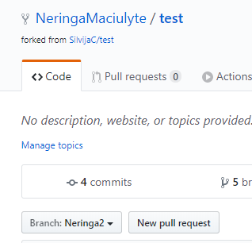

1. Click on the Fork button. Make sure the action is done by looking on the left as per below:

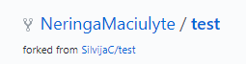

1. Upload the files into your branch (click on the ***Upload files*** button)
2. Enter a commit message
3. Leave ‚Commit directly to the *your NAME* branch‘ selected
4. Click Commit Changes
5. Make a pull request (there is a button named New Pull request or click on Compare and New pull Request). File added should appear at the top:

